SALADS AND STARTERS
Side Salad…………….......4.95
(lettuce, tomatoes, Gio’s Italian dressing)
Italian Salad……….…Sm 9.95…….…Lg 13.95
(lettuce, tomatoes, Gio’s Italian dressing, artichokes, olive salad)
Caprese Salad……….Sm 9.95………...Lg 13.95
(fresh mozzarella, fresh basil, tomatoes, balsamic vinegar)
Cheesebread…………….7.95
(8 pieces per order, served with red gravy)

POBOYS – all sandwiches are toasted
Meatball (best in the city)…………………11.95
Italian Sausage ……………………………..11.95
Chisesi Ham & Cheese…………………….11.95
Muffaletta .........(Half)11.95…..…(Whole)19.95
Muffaletta Special…………………………..13.95
(1/4 Muffaletta & small Italian Salad)
Chips (Assorted) …………………………….1.50

ENTREES – served with side salad & 2 pieces of garlic bread
Spaghetti & Red Gravy…………………...11.95
Spaghetti & Garlic & Olive Oil.…...…….12.95
Spaghetti & Meatballs (2).……………….14.95
Spaghetti & Italian Sausage ……………..14.95
Spaghetti Combo (Meatball/Sausage)…14.95
Chicken Parmesan………………………..14.95
Eggplant Parmesan……………………….14.95
Veal Parmesan…………………………….16.95
Lasagna …………………………………….16.95

SIDES
Side Meatball……………………………….3.95
Side Italian Sausage……………………….3.95
Side Red Gravy …………………………….2.00
Extra Garlic Bread………………………… .50

DESSERTS
Spumoni …………3.95
Cannoli …………..3.95
Fig Cookies ……..8.95 (when available)

DRINKS
Tea
Bottled Water
Soft Drinks
Domestic Beer –Mich Ultra, Bud Light, Miller Lite, Abita Amber
Imported Beer – Peroni, Moretti
PIZZAS
14” (cut into 8 slices)

Cheese (mozzarella, sauce)……………………………………………………………….14.95

Pepperoni (pepperoni, mozzarella)…………………………………………………….15.95

Bacon Cheeseburger (meatball, cheddar cheese, bacon) ……………………..19.95

Capri (ham, mushrooms, artichokes, black olives)…………………………………….19.95

Combo(pepperoni, mozzarella, Italian sausage, green peppers, onions, mushrooms, black olives)…………………………………………………………………………………….19.95

Gio’s Special (pepperoni, ham, onions, black olives, mushrooms)………………19.95

Greek (pesto sauce, spinach, black olives, feta, tomatoes)…………………………..19.95

Hawaiian (ham, bacon, pineapple)……………………………………………………...18.95

Italiano(Italian sausage, green peppers, banana peppers, onions)…………………19.95

Margherita (tomatoes, mozzarella, sweet basil)……………………………………...17.95

Meat (pepperoni, Italian Sausage, meatball, ham, bacon)…………………………….19.95

Muffaletta (ham, salami, homemade olive salad)……………………………………..19.95

Pesto (pesto sauce, spinach, artichoke hearts, feta)……………………………………19.95

Quattro Formagi (mozzarella, cheddar, provolone, feta)…………………………19.95

Veggie (green peppers, onions, mushrooms, black olives)…………………………17.95

1.00 2.00 4.00
pepperoni ham chicken
Italian sausage salami eggplant
black olives meatball
green peppers bacon
mushrooms artichoke hearts
onions feta
pineapple cheddar
spinach mozzarella
tomatoes olive salad
banana peppers
basil
garlic
jalapeno
anchovies
GRAB & GO READY-TO-EAT (fresh & refrigerated)
Italian, Caprese or Chef Salad…………...….Sm 9.95….…….……Lg 13.95
Homemade Meatballs w/ Gravy (4 per order)…….……..…….….....21.95
Italian Sausage w/ Gravy (4 per order) ……..…………..….…….…...21.95
Classic Lasagna (pint of red gravy) …………………….…..…….……34.95
Homemade Red Gravy (quart).………………………….….….............12.95
Gio's House Italian Dressing (pint)…………….…….……………………6.95
Garlic Bread (8 pieces)….……………………………….………………...3.95
Cannoli (4 per order)……………………...………………….….…….…14.95

FAMILY MEALS TO-GO SERVED HOT
(made to serve 4 – family style)

All meals served with:
Choice of Large Italian Salad or Caprese Salad
Pasta with Red Gravy
Garlic Bread (8 pieces)

Choice of the following entrees:
(Choose 1)

64.95 : Spaghetti & Meatballs (8 meatballs)
Spaghetti & Italian Sausage (8 sausages)
Spaghetti Combo (4 meatballs & 4 sausages)
Chicken Parmesan
Eggplant Parmesan

72.95 : Veal Parmesan
Lasagna

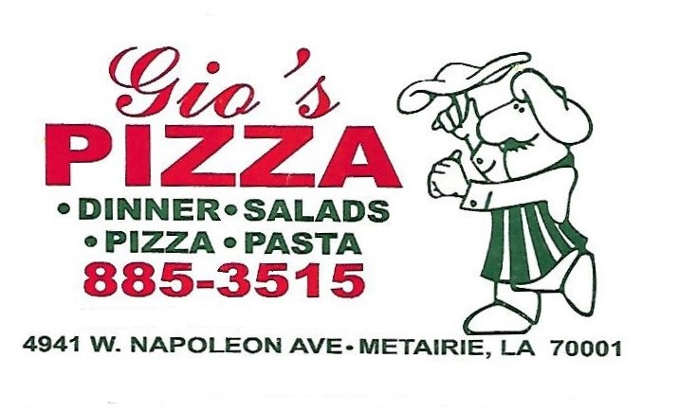

www.giospizza1984.com

Tuesday 11:00am – 2:00pm

Wednesday 11:00am – 2:00pm
4:00pm – 7:30pm

Thursday 11:00am – 2:00pm
4:00pm – 7:30pm

Friday 11:00am – 2:00pm
4:00pm – 8:00pm

Saturday 4:00pm – 8:00pm

DINE-IN OR CARRY-OUT
ALL MAJOR CREDIT CARDS ACCEPTED

Catering Available – Call for more info

